**INTRODUCTION**

**PROJECT TITLE: FITFLEX**

FitFlex is an innovative fitness web application designed to help users achieve their health and wellness goals with ease. Whether you are a beginner or a seasoned athlete, FitFlex offers a personalized and dynamic experience tailored to your unique fitness journey. The app provides a wide range of workout routines, nutrition plans, progress tracking, and expert advice, all in one place. With an intuitive interface, motivational tools, and the ability to track your fitness milestones, FitFlex ensures you stay motivated, informed, and on track toward living your healthiest life.

**TEAM MEMBER:**

1.Swathi.S - **TEAM LEADER**(Implementation) (swathisagayaraj@gmail.com)

2.Swathy.R– **TEAM MEMBER**(Implementation)(swathy300605@gmail.com)

3.Thilothama.R – **TEAM MEMBER(**Documentation)(thilothama428@gmail.com)

4.Thulasi.T– **TEAM MEMBER**(Documentation) (dnarmadha77@gmail.com)

5.Trisha. S– **TEAM MEMBER**(Documentation)(trishasrinivas20041021@gmail.com)

**PROJECT OVERVIEW**

**Purpose:**  
FitFlex is an innovative fitness web application designed to empower users to take control of their health and wellness. Our purpose is to provide a comprehensive platform that offers personalized workout routines, meal plans, and fitness tracking tools, all in one place. Whether you're a beginner looking to get started or an experienced athlete aiming to optimize your performance, FitFlex aims to make fitness accessible, engaging, and effective for everyone.

**Features:**

**Personalized Workout Plans:** Tailored routines based on your fitness goals, level, and preferences.  
**✓ Nutrition & Meal Plans**: Customized meal plans with calorie tracking and healthy recipes. **✓ Progress Tracking**: Tools to monitor workout progress, calories burned, weight loss, and more.  
**✓Expert Advice:** Access fitness tips, health insights, and motivation from certified professionals.  
**✓ Intuitive & User-Friendly Design:** Seamless experience with a clean, modern interface. **✓ Search & Filter Feature:** Easily find workout routines, meal plans, and tips with intuitive search options.

**ARCHITECTURE**

The user experience for **FitFlex** begins with a clean, intuitive UI likely built with a framework such as React or Vue.js to ensure a smooth, single-page experience. This UI communicates with an API client designed specifically for **FitFlex**. The client facilitates communication with the backend and integrates seamlessly with external data sources, potentially leveraging fitness and nutrition-related APIs to enrich the user experience.

**COMPONENT STRUCTURE:**

1. **App**: The top-level component that wraps the entire application and manages routing and global state.
2. **Header**: A navigation bar that contains links to key pages, such as Workouts, Meal Plans, Progress, etc.
3. **Footer**: Contains copyright information, links to privacy policies, and social media icons.
4. **Main**: A container that handles routing and serves as a wrapper for core components.
5. **WorkoutList**: A component that displays a list of available workout routines.
6. **WorkoutDetail**: A component that shows detailed information about a specific workout, including steps, videos, and tips.
7. **MealPlanList**: A component that displays a collection of meal plans.
8. **MealPlanDetail**: A component that provides details of a selected meal plan, including recipes and nutritional information.
9. **SearchBar**: A component that enables users to search for workout routines, meal plans, or fitness tips.
10. **UserProfile**: A component to display and update user profile information, including fitness goals and progress.

**STATE MANAGEMENT:**

**FitFlex** will use the **Context API** for state management. This approach allows for shared global state across the application, eliminating the need to pass props manually between components. A Context component will wrap the entire app, providing global state, which individual components .

**Routing:**

The routing structure for **FitFlex** will be handled by **React Router**, ensuring smooth navigation between different parts of the app. Here's an outline of how routing will be structured:

1. **Installing React Router:** To use React Router in your project, install it using the following command:
2. **Folder Structure:** The project will have the following folder structure:

* **Pages Folder** → Contains different pages accessed via unique URLs, such as Home, Workouts, Meal Plans, etc.
* **Components Folder** → Contains reusable components like Header, Footer, WorkoutList, etc.
* **Styles Folder** → Contains CSS files for styling the application.

1. **Routing Configuration:** The App.js (or App.tsx for TypeScript) file will set up routing using **react-router-dom**:

import { BrowserRouter as Router, Routes, Route } from "react-router-dom";

import Home from "./pages/Home";

import Workouts from "./pages/Workouts";

import MealPlans from "./pages/MealPlans";

import Progress from "./pages/Progress";

import Navbar from "./components/Navbar";

function App() {

return (

<Router>

<Navbar />

<Routes>

<Route path="/" element={<Home />} />

<Route path="/workouts" element={<Workouts />} />

<Route path="/mealplans" element={<MealPlans />} />

<Route path="/progress" element={<Progress />} />

</Routes>

</Router>

);

}

export default App;

This structure keeps the app modular and easy to navigate. The **FitFlex** app will offer a scalable solution for users to manage their fitness journey, from workout plans to progress tracking, in a seamless, user-friendly interface.

**4. Explanation of Routes:**

* **/ →** Loads the **Home** page, which provides an overview of the user's fitness progress and featured workouts or meal plans.
* **/workouts →** Loads the list of available **Workouts**, displaying different workout routines to choose from.
* **/workout/:id →** Displays detailed information about a specific **Workout** (e.g., exercises, duration, difficulty, tips, etc.).
* **/mealplans →** Loads the list of available **Meal Plans**, featuring different nutrition plans based on fitness goals.
* **/mealplan/:id →** Displays detailed information about a specific **Meal Plan**, including recipes and nutritional info.
* **/progress →** Loads the **Progress** page where users can view and track their fitness achievements over time.

**SETUP INSTRUCTIONS**

**Prerequisites:**

1. **Node.js:** The latest version of Node.js (LTS or higher) installed on your system.
2. **npm**: The latest version of npm (the package manager for Node.js) installed on your system.
3. **Git:** The latest version of Git installed on your system.

**INSTRUCTIONS**

* + **Clone the repository:**  
    Run the following command in your terminal to clone the **FitFlex** repository:
  + **Navigate to the project directory:**  
    Run the following command to navigate to the **FitFlex** project directory:
  + **Install dependencies:**  
    Run the following command to install the project dependencies:
  + **Configure environment variables:**  
    Create a new file named .env in the project root directory and add the following environment variables:
* **Start the application:**  
  Run the following command to start the application

**Folder Structure**

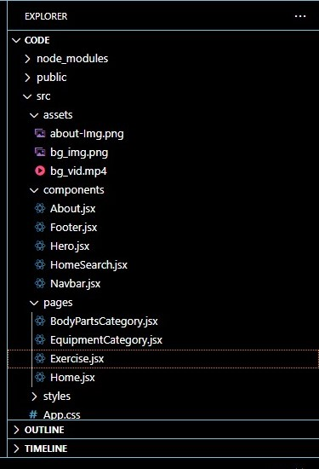

**Utilities**

Utilities in the app may include functions or helper files that provide reusable logic, such as formatting dates, validating user input, or managing API requests. These functions help streamline development and reduce redundancy throughout the project.

**Explanation of Category.js Component**

This React component is responsible for displaying a list of workouts or meal plans from a selected category. It fetches data from an API and allows users to navigate between different categories.

**1️. Importing Dependencies**

javascript

Copy

import React, { useEffect, useState } from 'react';

import '../styles/CategoryPage.css';

import { useNavigate, useParams } from 'react-router-dom';

import axios from 'axios';

* **React and useEffect**: These are essential for the React component and handling side effects (like API calls).
* **useNavigate**: Allows programmatic navigation between routes.
* **useParams**: Retrieves the category ID from the URL parameters.
* **axios**: Used to handle API requests.
* **CSS (CategoryPage.css)**: Styles for the page.

**2️. Defining the Component**

javascript

Copy

const Category = () => {

const [data, setData] = useState([]); // State to store fetched data

const { categoryName } = useParams(); // Get the category name from the URL

const navigate = useNavigate(); // Used to navigate programmatically

useEffect(() => {

// Fetch data from the API

axios.get(`https://api.fitflx.com/category/${categoryName}`)

.then(response => setData(response.data))

.catch(error => console.log(error));

}, [categoryName]); // Dependency array ensures that data is fetched when category changes

return (

<div className="category-page">

<h1>{categoryName}</h1>

<div className="category-list">

{data.map(item => (

<div className="category-item" key={item.id}>

<img src={item.image} alt={item.name} />

<h3>{item.name}</h3>

<button onClick={() => navigate(`/category/${categoryName}/${item.id}`)}>View Details</button>

</div>

))}

</div>

</div>

);

};

export default Category;

**Explanation:**

* **State Management**: data is used to store the list of meals or workouts fetched from the API.
* **API Call**: The useEffect hook triggers an API call to fetch the category data whenever the categoryName in the URL changes.
* **Navigation**: The useNavigate hook is used to navigate to a detailed page for each item when the button is clicked.
* **Rendering**: The component maps through the data and displays each item with an image, title, and a button that redirects the user to a details page.

1. **Fetching Category Data from API**

**Use Effect Hook (React)**

useEffect(() => {

fetchItems(id);

}, [id]); // Runs when the category ID changes

✔ Runs fetchItems(id) whenever the category ID changes  
✔ Ensures the component re-fetches data when navigating between categories

**API call function**

const fetchItems = async (categoryId) => {

try {

const response = await axios.get(`https://api.fitflex.com/categories/${categoryId}/items`);

setItems(response.data.items); // Store items in state

console.log(response.data.items); // Debugging: logs API response

} catch (error) {

console.error(error); // Handles errors

}

};

* Makes an API request to fetch items based on category (categoryId)
* Stores the response (response.data.items) in state (setItems)
* Handles errors with catch(error => console.error(error))

1. **UI Layout**

**Header Section**

<div className="categorypage-head">

<h2>Category: <i>{id}</i></h2>

<div className='categorypage-head-options'>

<p>Other popular categories:</p>

<span>

<button onClick={()=>{ navigate(`/category/Strength`); fetchItems('Strength')} }>Strength</button>

<button onClick={()=> {navigate(`/category/Cardio`); fetchItems('Cardio')}}>Cardio</button>

<button onClick={()=> {navigate(`/category/Endurance`); fetchItems('Endurance')}}>Endurance</button>

<button onClick={()=> {navigate(`/category/Flexibility`); fetchItems('Flexibility')}}>Flexibility</button>

<button onClick={()=> {navigate(`/category/Recovery`); fetchItems('Recovery')}}>Recovery</button>

</span>

</div>

</div>

* Dynamically displays the selected category ({id})
* Includes buttons for other popular categories
* Click the button
* Navigates to a new category (navigate('/category/Strength'))
* Fetches the relevant category items (fetchItems('Strength'))

**Displaying Fetched Exercises**

<div className="categorypage-body">

{items ? (

<div className="exercise-items">

{items.map((item) => (

<div className="exercise-item" onClick={()=> navigate(`/exercise/${item.id}`)} key={item.id}>

<img src={item.thumbnail} alt="exercise-thumbnail" />

<h4>{item.name}</h4>

</div>

))}

</div>

) : "Loading..."}

</div>

* Checks if items exist before rendering
* Maps over items array to display each exercise
* Thumbnail (item.thumbnail)
* Name (item.name)
* **On Click:** Navigates to exercise details page (/exercise/${item.id})

**5.Exporting the Component**

**Javascript:**

export default Category;

* Allows this component to be imported and used elsewhere in the FitFlex project.

**Running the Application**

**✓ Get the code:**

• Download the code from the drive link given below:

<https://drive.google.com/drive/folders/14f9eBQ5W7VrLdPhP2W6PzOU_HCy8UMex?usp=sharing>

**Install Dependencies:**

• Navigate into the cloned repository directory and install libraries:

cd fitness-app-react

npm install

**✔ Start the Development Server:**

• To start the development server, execute the following command:

npm start

**Access the App:**

• Open your web browser and navigate to http://localhost:3000.

• You should see the application's homepage, indicating that the installation

and setup were successful.

**Component Documentation**

**Key Components**

**1. Navbar Component**

✔ **Purpose:** Provides navigation throughout the application.  
✔ **Props:**

* links (array): List of navigation links.
* logo (string): URL for the logo image.

**2. Hero Component**

✔ **Purpose:** Serves as the main banner, introducing the application with a call-to-action button.  
✔ **Props:**

* title (string): Main heading text.
* description (string): Short description of the app.
* ctaText (string): Call-to-action button text.

**3. Popular Categories Component**

✔ **Purpose:** Displays a list of popular **workout categories**.  
✔ **Props:**

* categories (array): List of category objects containing id, name, and image.

**4. Trending Workouts Component**

✔ **Purpose:** Highlights trending workouts with images.  
✔ **Props:**

* workouts (array): List of workout objects containing id, name, image, and rating.

**5. Category Page Component**

✔ **Purpose:** Displays a list of **workouts** based on the selected category.  
✔ **Props:**

* category (string): Selected category name.
* workouts (array): List of workouts in the category.

**6. Workout Details Page Component**

✔ **Purpose:** Displays detailed information about a selected **workout**.  
✔ **Props:**

* workout (object): Contains workout details such as name, muscle groups, instructions, image, and videoUrl.

**7. Newsletter Subscription Component**

✔ **Purpose:** Allows users to subscribe to a newsletter for **fitness updates**.  
✔ **Props:**

* onSubscribe (function): Function to handle user subscription.

**Reusable Components**

**1. Button Component**

✔ **Purpose:** A customizable button used throughout the app.  
✔ **Props:**

* text (string): Button label.
* onClick (function): Click handler.
* variant (string): Style variant (primary, secondary, etc.).
* disabled (boolean): Whether the button is disabled.

**2. Card Component**

✔ **Purpose:** Displays information in a card format.  
✔ **Props:**

* title (string): Card title.
* image (string): URL for the card image.
* description (string): Short text description.
* onClick (function): Click handler.

**3. Loader Component**

✔ **Purpose:** Displays a loading animation while fetching data.  
✔ **Props:**

* size (string): Size of the loader (small, medium, large).
* color (string): Color of the loader.

**4. Search Bar Component**

✔ **Purpose:** Allows users to search for **workouts or exercises**.  
✔ **Props:**

* onSearch (function): Function to handle search input.
* placeholder (string): Placeholder text for the input field.

**5. Modal Component**

✔ **Purpose:** Displays pop-up dialogs (e.g., detailed workout instructions).  
✔ **Props:**

* isOpen (boolean): Controls visibility.
* onClose (function): Function to close the modal.
* content (JSX): The content to be displayed inside the modal.

**State Management**

State management is the practice of handling application state, ensuring data consistency and responsiveness in **FitFlex**.

**1. Global State**

Global state refers to data shared across multiple components. It is usually managed using state management tools like **Redux** or **Context API**.

**What to Document?**

✔ **State Variables:** The global states and their purposes.  
✔ **State Flow:** How state updates propagate in the application.  
✔ **State Management Tools:** Frameworks or libraries used (**Redux, Context API**).

**Example (React Context API - Managing Workout Theme Mode)**

import React, { createContext, useState, useContext } from "react";

const ThemeContext = createContext();

export function ThemeProvider({ children }) {

const [theme, setTheme] = useState("light");

return (

<ThemeContext.Provider value={{ theme, setTheme }}>

{children}

</ThemeContext.Provider>

);

}

// Usage in App Component

function App() {

const { theme, setTheme } = useContext(ThemeContext);

return (

<div className={theme}>

<button onClick={() => setTheme(theme === "light" ? "dark" : "light")}>

Toggle Theme

</button>

</div>

);

}

**2. Local State**

Local state is confined to a single component and is used to manage **UI behavior, form inputs, or workout-specific data** in FitFlex.

**What to Document?**

✔ **State Variables:** Local states used within the component.  
✔ **State Management Methods:** Functions used to update the local state.  
✔ **Scope:** Where and how the local state is used.

**Example (React useState Hook - Managing Workout Count)**

**import { useState } from "react";**

**function WorkoutCounter() {**

**const [count, setCount] = useState(0);**

**return (**

**<div>**

**<p>Workouts Completed: {count}</p>**

**<button onClick={() => setCount(count + 1)}>Complete Workout</button>**

**</div>**

**);**

**}**

* Manages a workout completion count within the component.
* Updates state dynamically when the button is clicked.

**USER INTERFACE**

The document contains details about the FitFlex application, including its features, project setup, and API integration. However, for screenshots or GIFs showcasing different UI features, you might need to extract images from the document or from the demo link**.**

**🔗 Project Demo Link:****Demo Link**

**🔗 Code Repository & Assets:****Project Link**

**Styling**

**CSS Frameworks/Libraries**

@import url('https://fonts.googleapis.com/css2?family=Poppins:wght@200;300;400;500;600;700;800;900&family=Teko:wght@400;600;700&family=Whisper&display=swap');

body {

margin: 0;

font-family: 'Poppins', sans-serif;

-webkit-font-smoothing: antialiased;

-moz-osx-font-smoothing: grayscale;

}

code {

font-family: source-code-pro, Menlo, Monaco, Consolas, 'Courier New', monospace;

}

/* Font Choices for FitFlex */

font-family: 'Poppins', sans-serif; /* Modern and clean typography */

font-family: 'Teko', sans-serif; /* Bold and sporty look */

font-family: 'Whisper', cursive; /* Stylish cursive (for special highlights) */

**State Management**

In a React application, state management plays a crucial role in maintaining and updating data across various components. In FitFlex, state management is categorized into Global State and Local State.

**1.Global State Management**

**Global state** refers to data that needs to be accessed and updated across multiple components. Managing this efficiently ensures **consistency and enhances the user experience** in FitFlex.

**How Global State Flows Across the Application**

1. **Centralized Storage** – Global state is stored in a central location using tools like **React Context API, Redux, Recoil, or Zustand**.
2. **State Updates** – Components update the global state using **actions (Redux)** or **setters (Recoil/Zustand)** to ensure consistency.
3. **State Consumption** – Any component needing access to **workout data, user preferences, or fitness progress** can subscribe to the global state and receive updates.

**2.Local State Management**

**Local state** is used within **individual components** to manage **UI changes and interactions** without affecting other parts of the application.

**Handling Local State in Components**

1. **useState Hook** – Used for managing **simple component-level states** like **form inputs, modal visibility, or workout tracking**.
2. **useReducer Hook** – Helpful for **more complex state transitions** within a component, such as **handling multiple steps in a fitness routine**.

**Testing Strategy**

Testing is a crucial aspect of ensuring the **stability, reliability, and performance** of the **FitFlex** application. The testing strategy includes **unit testing, integration testing, and end-to-end (E2E) testing** using modern testing frameworks.

**1. Unit Testing**

**Unit testing** is performed on **individual components** to verify their functionality in isolation.

✔ **Tools Used:** Jest, React Testing Library  
✔ **Scope:**

* Test individual React components (**e.g., Navbar, WorkoutCard, PopularWorkouts**).
* Validate **component rendering and UI changes**.
* Check for **correct API calls** using mock functions (**e.g., Axios mocks**).
* Ensure **props and state updates** work correctly.

**2. Integration Testing**

**Integration tests** verify that **multiple components work together correctly**.

✔ **Tools Used:** Jest, React Testing Library, Mock Service Worker (**MSW**) for API mocking.  
✔ **Scope:**

* Verify **API data is fetched and displayed correctly** (**e.g., fetching workout categories**).
* Ensure **state management updates correctly** when interacting with the UI.
* Simulate **user interactions** like **button clicks and form submissions**.

**3. End-to-End (E2E) Testing**

**E2E tests** validate the **entire application flow**, ensuring all components work together as expected.

✔ **Tools Used:** Cypress, Playwright  
✔ **Scope:**

* Test **full user workflows**, such as **searching for workouts, navigating between pages, and viewing workout details**.
* Validate **UI elements are displayed correctly across different screen sizes**.
* Ensure **API calls and responses** are handled properly.

**Code Coverage**

To ensure **sufficient test coverage**, the following tools and techniques are used:

✔ Jest + Istanbul **(nyc):** Measures line, function, and statement coverage.  
✔ React Testing Library**:** Ensures important UI elements are tested.  
✔ Cypress Dashboard**:** Tracks E2E test execution and failure rates.

To generate a test coverage report, use:

npm test -- --coverage

This generates a report detailing which lines of code were tested.

**Screenshot**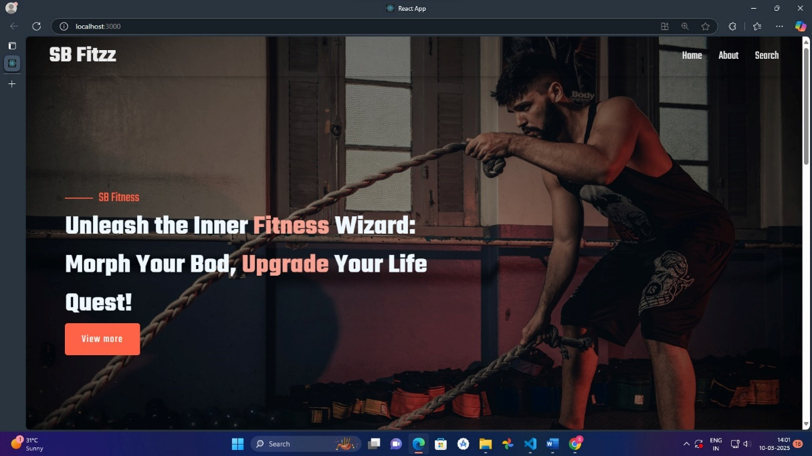

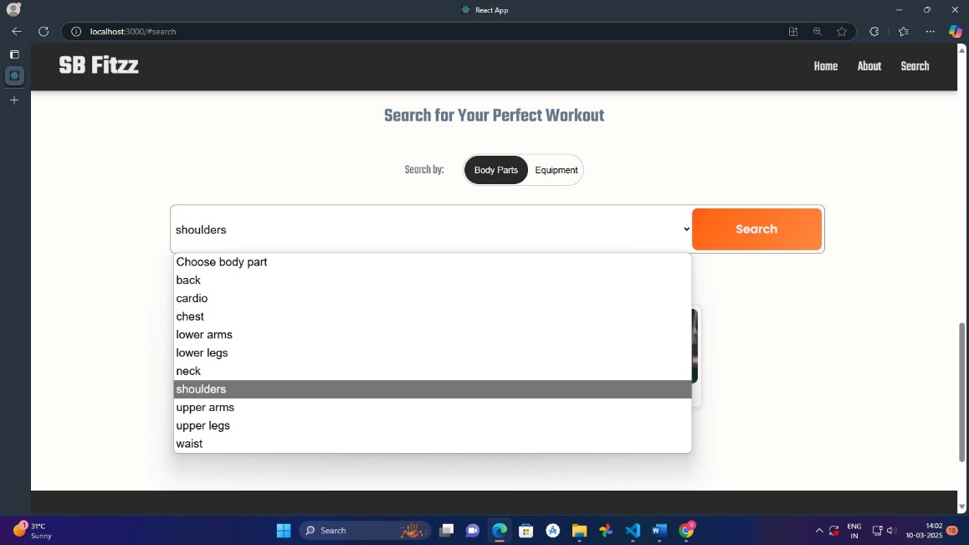

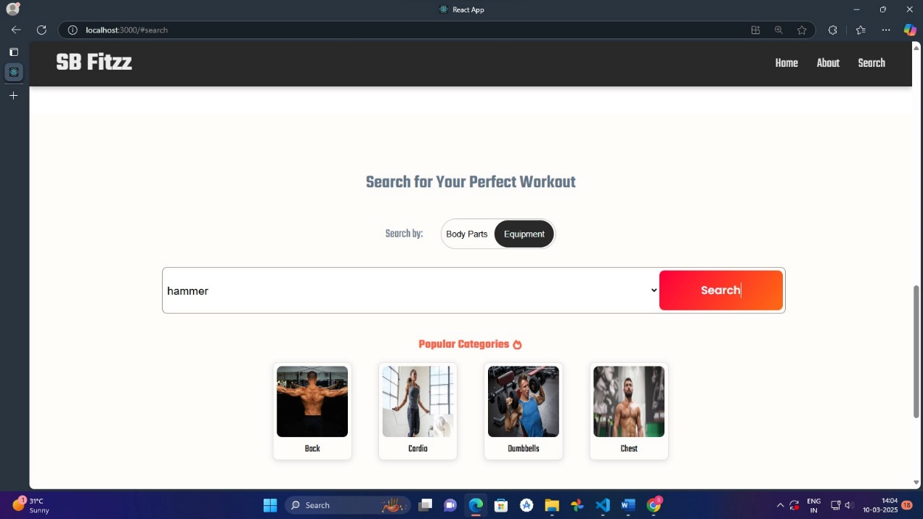

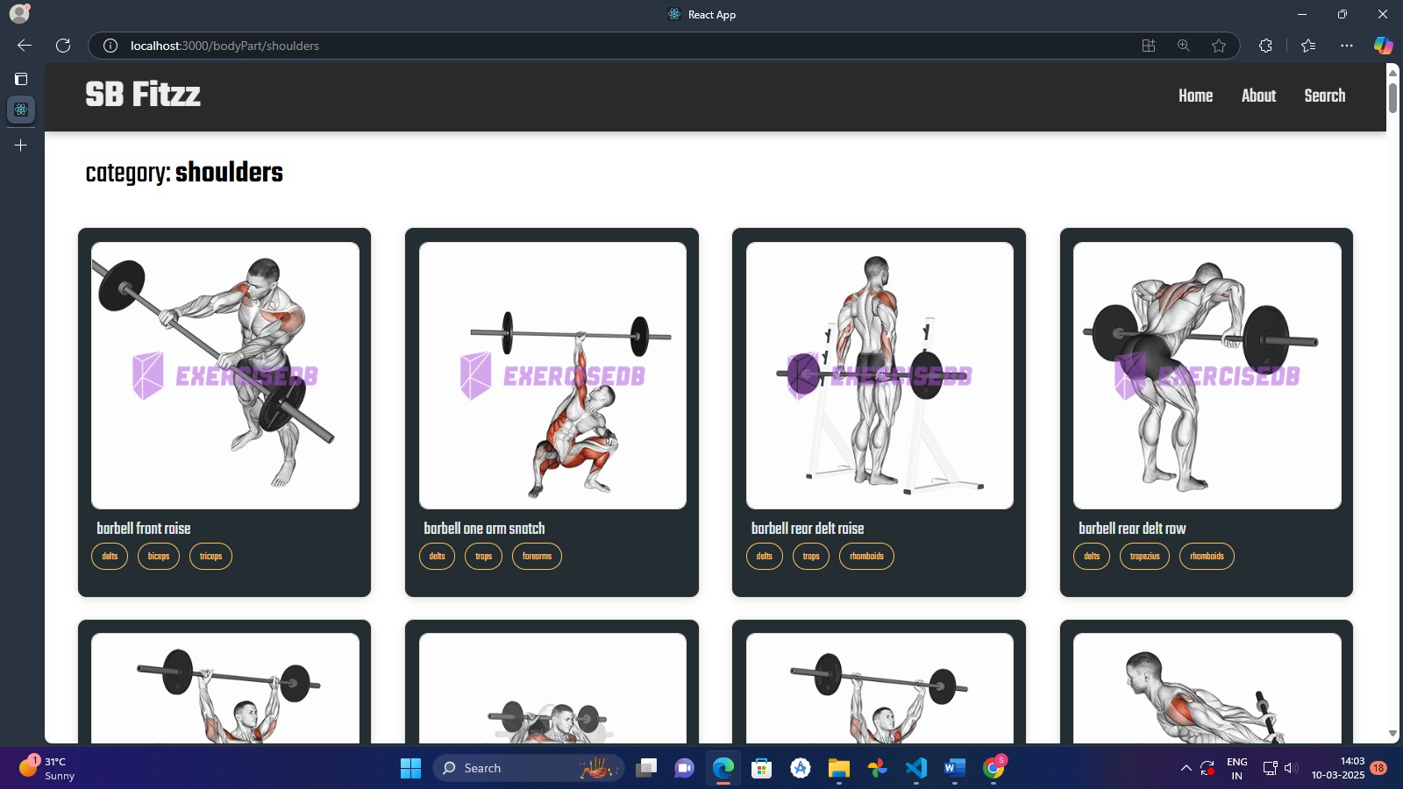

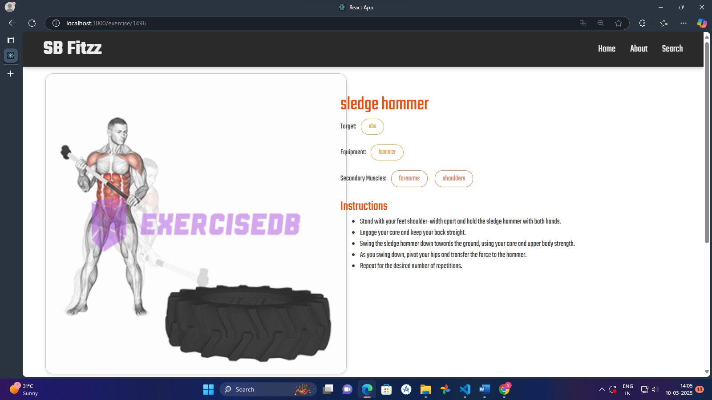

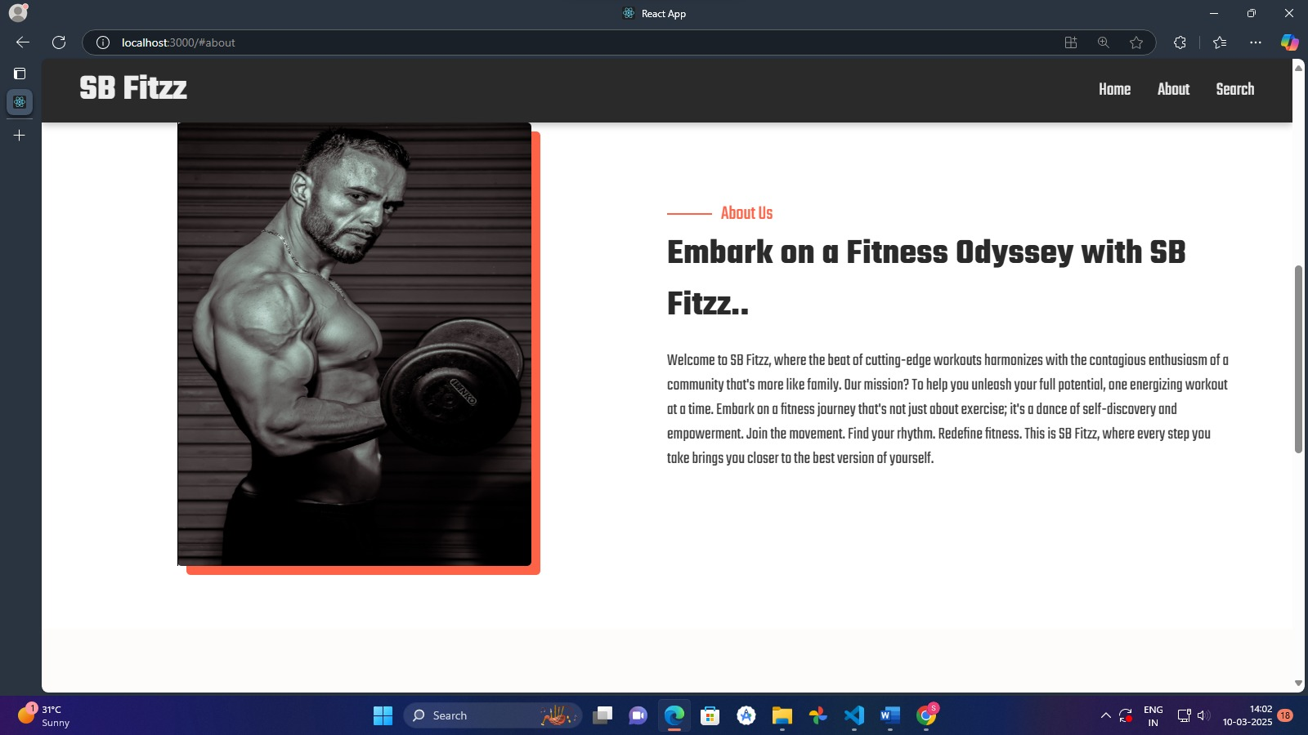

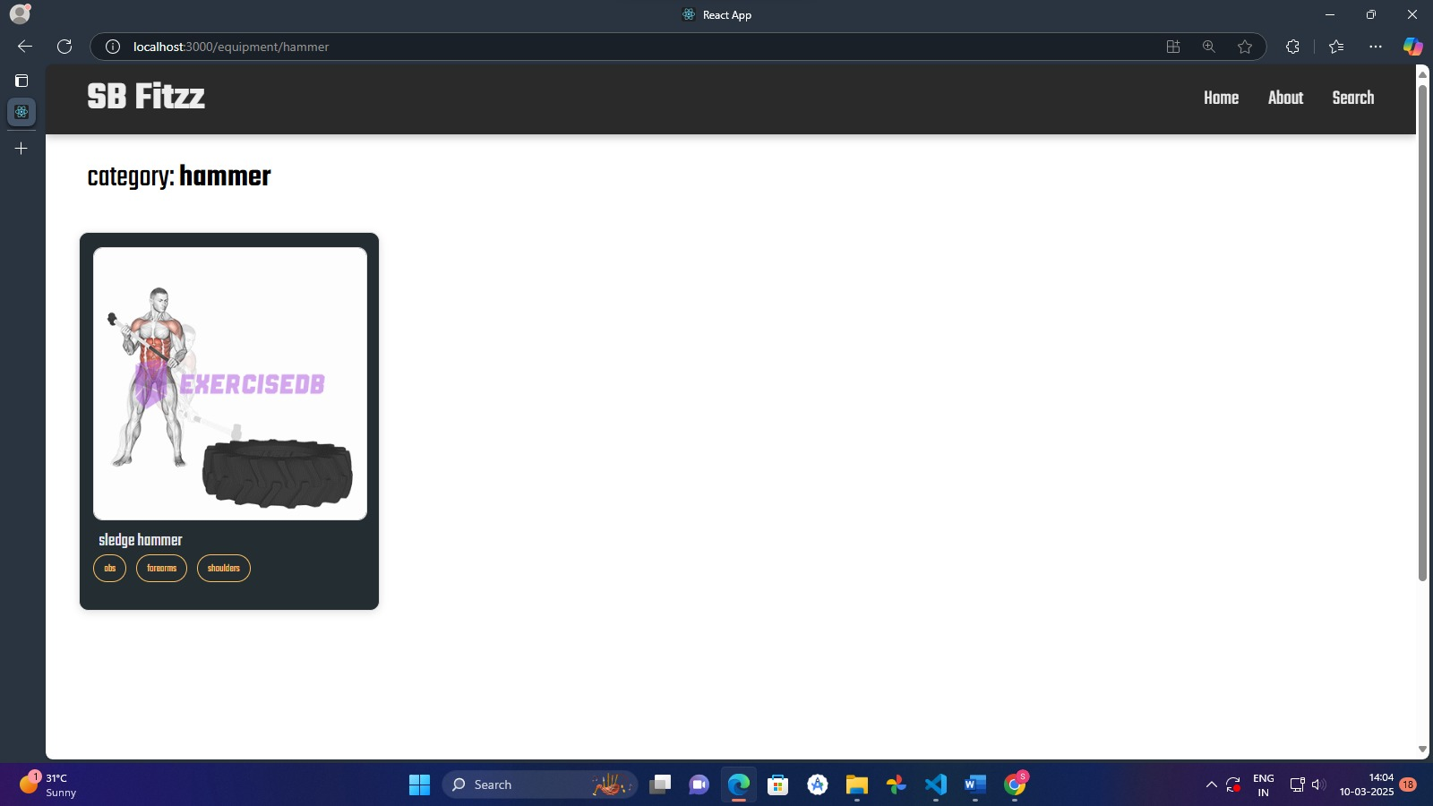



**Known Issues**

**1. API Limitations & Dependencies**

* **FitFlex** relies on external APIs for **workout and exercise data**. If the API service is **down or rate-limited**, the app may fail to fetch workout plans.
* Some **workout categories or exercise routines** might not always be available if they are removed from the API source.
* Potential **latency issues** when retrieving data from external sources, especially during **high traffic periods**.

**2. UI/UX Inconsistencies**

* Certain components (**such as category pages and workout details**) may **load slowly** due to **large image sizes** or API response times.
* The **search functionality** may not always return **relevant results** due to **limited filtering options**.
* The **mobile version** may have **minor responsiveness issues** on **smaller screens**.

**3. Error Handling & Edge Cases**

* If an **API request fails**, error messages **are not always displayed**, leading to an **unclear user experience**.
* No **caching mechanism** is implemented, leading to **repetitive API calls** even when navigating **back to previously loaded content**.
* If an **invalid workout ID** is provided, the app might **crash** instead of **gracefully handling** the error.

**4. Authentication & Security Concerns**

* **Currently, there is no user authentication implemented**, making it **impossible** for users to **save favorite workouts or track progress**.
* No **rate-limiting or request throttling** is in place, which could make the application **vulnerable** to excessive API requests.

**5. Code & Performance Optimization**

* The **useEffect() hook** calls API requests **without caching**, leading to **unnecessary re-fetching** of data.
* Some **components may re-render unnecessarily**, impacting **performance**, especially on **lower-end devices**.
* **Large dependencies** (e.g., **Bootstrap and Tailwind CSS being used together**) may **increase bundle size**, leading to **longer load times**.

**Future Enhancements**

**1. AI and Personalization**

* **AI-Based Workout Recommendations**: Implement **machine learning** to suggest **personalized workouts** based on user **preferences, past activities, and fitness goals**.
* **Voice Assistance Integration**: Enable **Google Assistant** or **Alexa** for **hands-free workout guidance** and real-time coaching.
* **Image Recognition for Exercises**: Allow users to **upload workout images or videos**, and the app will suggest **correct forms, techniques, or exercises** based on AI analysis.

**2. Community and Social Features**

* **User-Generated Workouts**: Allow users to **create, share, and customize** their own **workout plans** with the community.
* **Social Media Integration**: Enable users to **share fitness progress, workout stats, and achievements** on platforms like **Instagram, Facebook, and Twitter**.
* **Live Fitness Classes**: Introduce **live-streamed workouts** with certified trainers, where users can join real-time fitness sessions.

**3. Enhanced Features and Functionality**

* **Personalized Workout Plans**: Provide **tailored fitness routines** based on body type, fitness level, and goals (**weight loss, muscle gain, endurance, etc.**).
* **Diet and Nutrition Integration**: Offer **customized meal plans** to complement workout routines.
* **Progress Tracking & Analytics**: Implement **real-time performance tracking** with visual data insights like **calories burned, workout history, and fitness improvements**.

**4. Monetization Strategies**

* **Subscription-Based Model**: Introduce **premium membership** for access to **exclusive workout programs, expert coaching, and advanced analytics**.
* **Affiliate Marketing**: Partner with **fitness brands, gyms, and supplement companies** for promotions and affiliate sales.
* **Sponsored Workouts & Challenges**: Collaborate with **fitness influencers and trainers** to offer sponsored **workout challenges** and competitions.

**5. Cross-Platform Expansion**

* **Mobile App Development**: Expand **FitFlex** from a **web app** to **native mobile applications** on **iOS and Android**.
* **Smartwatch & Wearable Integration**: Sync workouts with **Apple Watch, Fitbit, and Garmin** to track real-time progress.
* **Augmented Reality (AR) Workouts**: Introduce **AR-based guided workout sessions**, allowing users to see 3D animations of exercises in their real environment.